Studio Space

Shed 11 boasts a huge floor area of 8 meters x 11.5 meters with a ceiling height of 2.8m. It also has a classic old rustic tin backdrop which is great for shooting old cars or motor bikes and adding a bit of grunge to a shoot, as well as a white infinity wall.

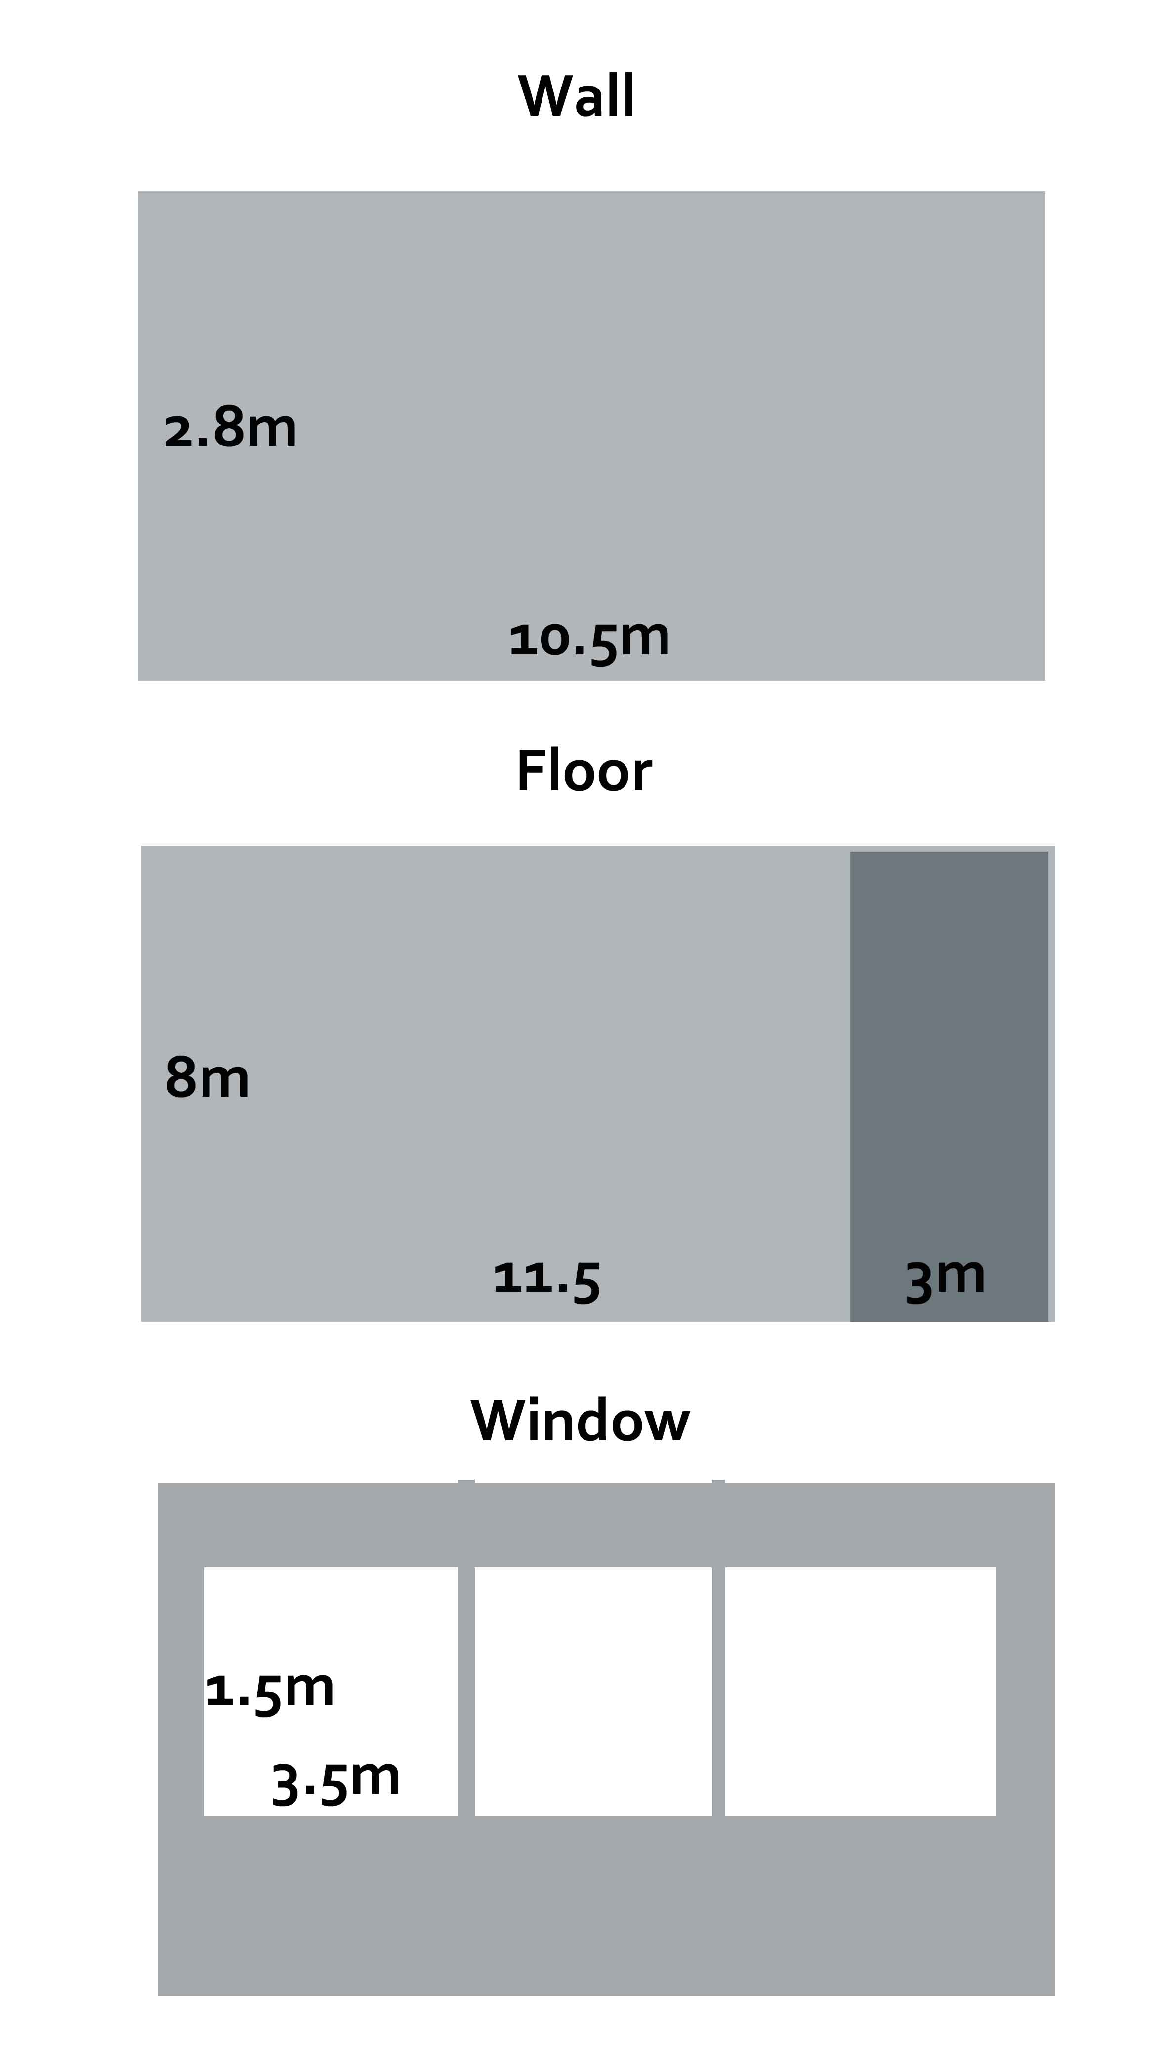
We also believe we are unique in it’s location, surrounded by lush open fields, horse fences and old timber buildings and a chapel. The ability to shoot product both inside and out without travel is a definite bonus.

We offer the option of studio hire with or without lighting and equipment as well as with or without a lighting technician.

Studio Hire
- Shed 11 is available for hire, with or without lighting and with or without a lighting technician.
- Rates apply as follows
  - A half day rate (4 hours) is $150.00 with no lighting equipment;
  - A half day rate (4 hours) with lighting equipment (see attached equipment list) is $250.00
  - A half day rate (4 hours) with lighting equipment plus qualified lighting technician is $350.00.
  - Additional time is charged at $ 50.00 per hour without lighting, $75.00 with lighting and $100.00 for lighting and lighting technician.
  - Full day rate (8 hours) is $250.00 with no lighting equipment;
  - Full day rate (8 hours) with lighting equipment (see attached equipment list) is $400.00
  - Full day rate (8 hours) with lighting equipment plus qualified lighting technician is $550.00.
  - Additional time is charged at $ 50.00 per hour without lighting, $75.00 with lighting and $100.00 for lighting and lighting technician.

- Coffee and tea making facilities are included in the hire rate
- Due to training and workshops, studio hire is available only Monday to Friday, 8am to 6pm only unless the studio is otherwise available. Please check with our admin when booking.
- A non-refundable 50% deposit is required at the time of booking, and this must be paid, with funds received by us within 48 hours prior to the hire date. The deposit should be made to ensure your booking is secured. Payment in full is required at the completion of the shoot.
- Any damage caused by the hirer or any of their staff or contractors, to any equipment will be the hirer’s responsibility, including the cost of. An estimate for such repairs will be obtained at the time of the occurrence and payment made directly to the repairers. Any shortfall will be subsequently invoiced to the hirer or a refund made if the cost is less than the estimate.
- Staff will be on the premises at all times to assist with initial set up and equipment familiarization.
- Smoking is strictly prohibited in and around the studio. Please check where designated smoking areas exist.
- There is no parking directly in front of the studio.
- Hirers must have their own Public Liability insurance for a minimum of $10,000,000.00. We will need a copy of a 'CERTIFICATE OF CURRENCY'
Prior to hire.
- Goods, or any equipment left or stored are done so at the hirers sole risk and the hirer will be responsible for any and all theft, damage and deteriorations of the goods, and shall bear the risk of any and all damage caused by flood or fire or leakage, animal, pest or vermin or any other reason whatsoever including
acts or omissions of the Owner or persons under its control.

Equipment List

4 x Bowen 400 Flash heads and stands
2 x Elinchrome Flash heads and stands
Umbrellas
Soft boxes
Snoot
Barndoor
Backlight cone
Reflectors (large and medium)
Product Table with continuous lights x 4
Backdrop stands and Backdrops. (Black & White Velvet)
Tripod x 2

